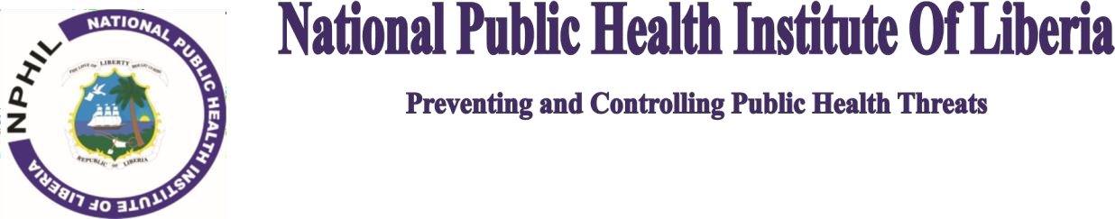

PRESS RELEASE

# NPHIL Confirms Monkeypox virus Clade-IIa in Liberia, Detected Three (3) New Mpox Cases

**MONROVIA – October 13, 2024:** The National Public Health Institute of Liberia (NPHIL) announces the **presence and circulation of the Monkeypox virus Clade-IIa in Liberia, based on molecular genetic sequencing results**. Meanwhile, NPHIL also announces that its National Reference Laboratory (NRL) has detected and confirmed three (3) new cases of Mpox in the country.

This brings to eleven (11) the number of positive confirmed cases in Liberia since the Declaration of Mpox as a Public Health Emergency of Continental and International Concern by the Africa Center for Disease Control and Prevention (ACDC) and the World Health Organization (WHO) in mid-August, 2024.

Liberia now has a total of seventeen (17) confirmed cases of Mpox since 1st January 2024 to today, 13th October 2024. Twelve (12) of these cases have recovered, zero (0) deaths recorded, while five (5) cases remained active to date.

This genomic evidence of Monkeypox virus Clade-IIa in Liberia was demonstrated by separate, but comparable results of genomic sequencing performed on samples sent from NPHIL to the US National Institutes of Health (NIH) and the Nigeria Center for Disease Control and Prevention (NCDC). This work was facilitated by the NIH-PREVAIL-Liberia and the WHO-Liberia Country office.

“Knowledge of the existence of the Mpox Clade-IIa circulating in Liberia provides important scientific information about the genomic epidemiology of the Monkeypox virus in Liberia, how NPHIL addresses issues of vaccines, how the institute approaches matters of diagnostics, and how it provides us information on how the virus may be spreading from animal-to-person or from person-to-person,” Dr. Dougbeh Chris Nyan, NPHIL Director General said.

Meanwhile, NPHIL continues to concurrently respond to multiple outbreaks and public health emergencies including Lassa, Measles, and Rubella, while the National Incident Management System (IMS) mobilizes resources and coordinates the national response to the continental and global Mpox outbreak declared by the Africa-CDC and the WHO.

As the National Incident Management System (IMS) coordinates and manages the country’s outbreak preparedness and response, we admonish the population to remain calm, wash/sanitized your hands, avoid contact with suspected persons and animals, and also strongly advised to practice safe and protected sexual behaviour. Citizens, residents, and communities are also advised to report suspected cases of Mpox to the nearest health facilities and authorities.

Signed:



# Dougbeh Chris Nyan, M.D.

Director-General/NPHIL