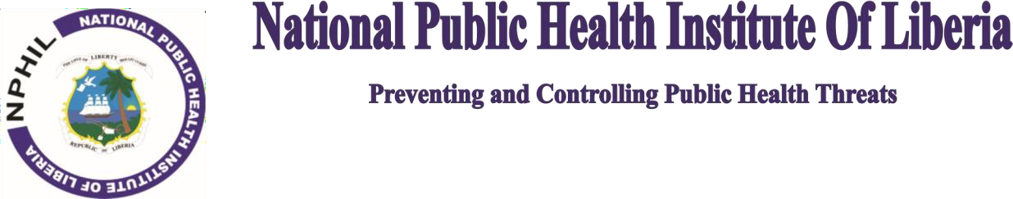

PRESS RELEASE

**Liberian Scientists Detect and Identify Monkeypox virus Clade-IIb, Zero Deaths from Mpox Cases**

**MONROVIA – November 4, 2024:** The National Public Health Institute of Liberia (NPHIL) announces that **Liberian scientists have acquired genomic sequencing detected and identified Monkeypox virus Clade IIb in the country. Also, Liberia has Zero (0) deaths recorded to date,** thus giving Liberia a zero percent case fatality rate (0% CFR) in the region since the global and continental Mpox outbreak was declared by the WHO and the Africa Centers for Disease Control (ACDC) in August this year, 2024.

As of the Epidemiological Week Number 43, Liberia now has zero (0) deaths, fourteen (14) Recovered Cases, and only eight (8) Active Cases to date as reported by Liberia’s Mpox Incident Management System (IMS) presentation by the NPHIL to the weekly Africa-CDC Continental Public Health Director-Generals meeting this week.

“Acquiring full biomolecular sequencing capability now gives Liberia’s National Reference Laboratory of the NPHIL the ability to promptly identify pathogen-types (including viruses and bacteria) in-country, right here in Liberia, without sending specimens outside of the country,” said Dr. Dougbeh Chris Nyan, a biomedical scientist and current Director-General of NPHIL.

“Genomic Sequencing is a special laboratory technique that allows scientists to know the arrangements of the DNA or RNA or protein in an organism. In this situation, the technique then enables us to know if the pathogen has change [mutated] its genes as well as allows us to determine the origin or classification of the pathogens,” Dr. Nyan added.

Previously, specimens were sent to the NIH in the US and the NCDC in Nigeria, and the results revealed the existence of the Mpox Clade-IIa circulating in Liberia. With Liberian scientists also detecting a second type (Clade IIb) of the Monkeypox virus in the country, this new genomic evidence provides the NPHIL with directions on preparedness and response, approaches to vaccines and diagnostics, tracing the origin of the virus, and investigating its mode of transmission from animal-to-humans or from human-to-human in the communities, the NPHIL Director-General emphasized.

“This important technical capability of being able to sequence the genomes right here in Liberia at the National Reference Lab was achieved thanks to the support of the WHO-Liberia Country Office through a Team of experts from the Noguchi Medical Memorial Institute of Ghana. Thanks also to the Africa CDC, US-CDC, USAID and all partners for the collective support to the NPHIL,” Dr. Nyan mentioned.

As the NPHIL and the National Incident Management System (IMS) also respond to the Lassa, Measles, and Rubella outbreaks, NPHIL admonishes the population to remain calm, follow all health sanitation regulations, avoid person-to-person contact, and practice protective sexual behaviour.

N-#-L

